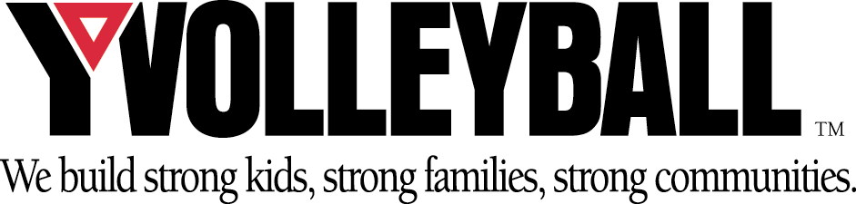
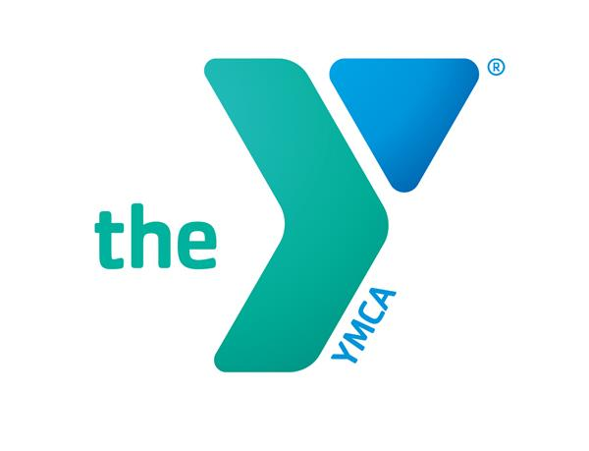Hamilton Family YMCA Youth Volleyball Spring 2025

Ages: 7 – 15 year old girls. Age divisions will be broken down as follows: 7 – 9, 10 – 12, 13 – 15 year old girls.

Cost: $85 (members) $115 (non-members)

Dates: Open registration begins on January 8 and ends March 2nd. Registration forms submitted after March 2nd, 2025 will be charged a $10 late fee if there is still room in the league. Practice will begin the week of March 24th. Games will be played on March 29, April 5, 12, 19, 26 May 3, 10, 17th.

Teams: Teams rosters are comprised of 9 to 12 players. SPECIAL REQUESTS ARE NOT GUARANTEED.

Coaches: All coaches are volunteers. If you are interested in coaching, please be sure to indicate it on your child’s registration form. Coaches are always needed! Coaches Meeting will be Wednesday March 5th at 6:00PM.

Site: Practices and games will be held at the Hamilton YMCA.

Games: All regular season games are scheduled for Saturdays. Games will begin at approximately 9:00 AM and last until each team has played their game for the week. Each team is guaranteed and scheduled 7 games during the season.

Tournament: All teams in each division will end the season with a random draw, single elimination tournament.

Staff/Referees: One referee will be on hand to officiate and supervise all games.

Uniform: Each child will be given a YMCA volleyball jersey. Parents must provide shorts for their child; black shorts are recommended. Shoes must be rubber-soled athletic shoes. All girls are encouraged to wear knee pads.

Sponsors: Team sponsors are needed for the upcoming season. Cost to sponsor a team is $150. Sponsorship dollars benefit the Hamilton YMCA Community Support Campaign. Please contact the Hamilton YMCA for more info.

Other: Now that you’ve registered, you’re simply waiting for a phone call or email. All players should be contacted by their coach or the YMCA between March 6th -14th. For any additional information, contact the YMCA at 423.899.1721.

