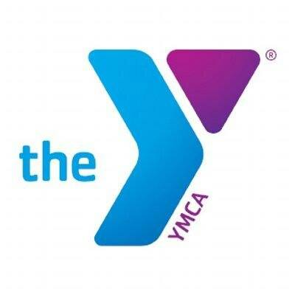
Grades | Teams are based on grade levels, typically divisions are K-2nd grade, and 3rd-5th grade
Program Dates | Open registration: July 24th- August 26th. Registrations received after August 26th will be charged a $15 late fee.  Practices will begin the week of September 11th, (no practices 10/9-10/13)  Games will be the following Saturdays: 9/16, 9/23, 9/30, 10/7, (no games 10/14), 10/21, 10/28, 11/4, 11/11
Times | Teams practice 1 day a week for 1 hour (which day depends on player and coach availability)  All games will be played on Saturday.
Cost | $75 members; $100 non-members  Registrations received after August 26th will be charged a $15 late fee.
Skill Level | Groups are made up of recreational players of all skill levels and backgrounds. Beginners are welcome and encouraged to participate in the YMCA program. Coaches will work with each player based on their needs for growth in each skill area of the game. This is a recreational league that focuses on having fun and learning the basics of the sport.
Teams | Teams are made up of 6-12 players each. YMCA staff will divide the teams according to skill level. Special requests are not guaranteed.
Coaches | All coaches are volunteers and have passed a criminal background check. If you are interested in coaching, please be sure to indicate that on your player’s registration form. Coaches will be trained by the YMCA Sports Staff on rules, procedures, and general knowledge as needed.
Uniforms | The YMCA will provide a team t-shirt. MOUTH GUARDS ARE REQUIRED for your child to play. Cleats are recommended, but not required. Please have your player wear athletic pants or shorts.
Pictures | Team pictures (and individual pictures if wanted) will be taken on one of the game days. More details will be given once the season has started.
What’s Next? | Once you have registered, you’re simply waiting on an email. All players will receive an email from their coach or the YMCA (by 9/11). If you do not receive communication from the coach or YMCA by the above date, email bdalton@ymcachattanooga.org

